LPG DISTRIBUTION  
SYSTEM

Activity & Sequence Diagram

Devendrakumar Raiyani (17CEUOG022 – CE107)  
Smit Patel (17CEUOS110 – CE095)

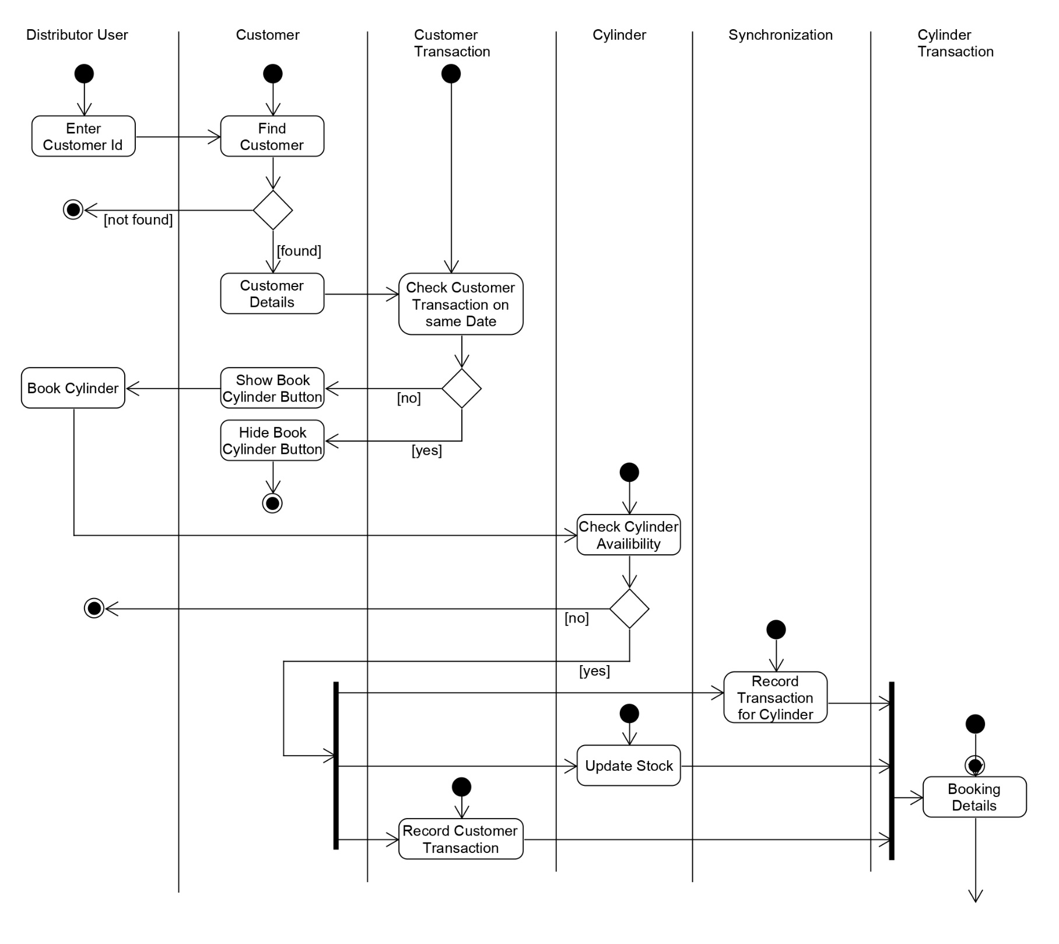**Activity Diagram for Book Cylinder**

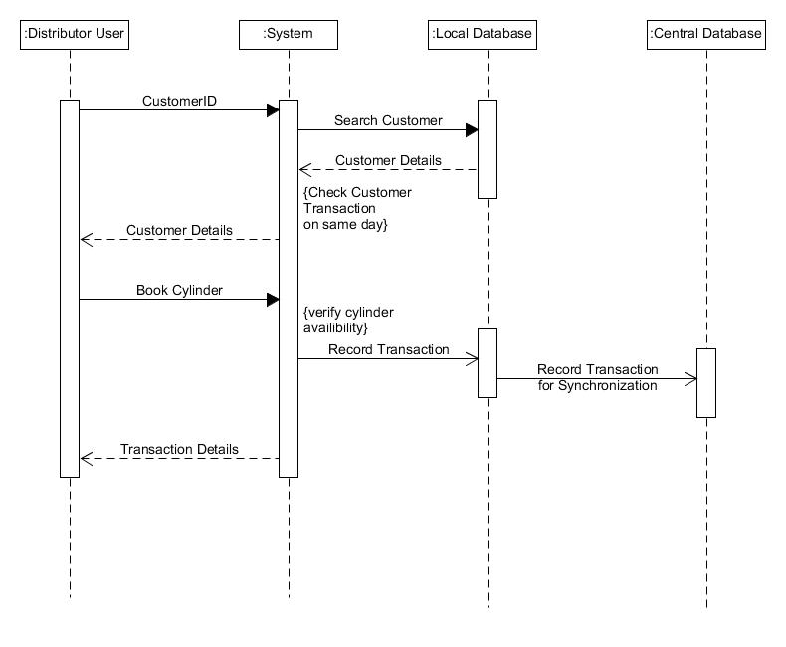**Sequence Diagram for Book Cylinder**